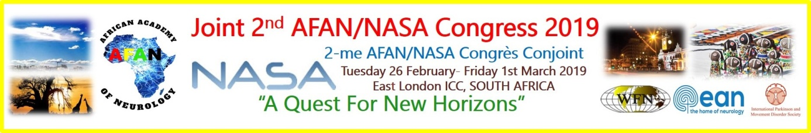
Invitation to AFAN/ NASA - 2019
It is an honour and privilege for me to extend an invitation to the Neurology family of South Africa to the next annual NASA conference (NASA 2019). The uniqueness of this coming conference is that for the first time in NASA’s history, we will be sharing the platform with our African brothers and sisters from the rest of the continent in the form of AFAN (African Academy of Neurology).
The aim is to make this a very worthwhile experience for everyone. To share ideas and to form an even stronger nexus with the rest of the continent, in so doing, abolishing academic boundaries that might have been isolating our respective countries. International speakers will give flavour from beyond the African shores, providing a glimpse of activities and strategies from far yonder. The theme of the conference is “a quest for new horizons” which is befitting of the underpinning logic, the engine that drives conferences of this nature.
The venue will be in East London, a coastal town in the Eastern Cape province with an excellent conference ICC (International Convention Centre) facility. This facility is abundantly spacious with an amphitheatre style auditorium and supporting chambers. The conference centre which is situated along the beach front is hugged by high-quality hotels of various grades to suit your pocket. The plan is to have the program not too tightly packed so as to have time to mingle and chat with friends and colleagues. The dates have been slightly altered from the normal NASA programs in that we are set to have this at the end of February to beginning March. This was a mutually agreeable date between NASA and AFAN. Another variation to the norm is that we will be starting on a Tuesday late morning instead of a Wednesday, the last day being Friday, noon. The latter arrangement was informed by flights which become scanty on weekends.
I am looking forward to seeing you in East London and be rest assured that a lot of hard work would have gone into putting up a program that you will hopefully enjoy.
Sincerely,
Dali Magazi
Conference chairperson (NASA)

